User Guide for Website Navigation

Table of Contents

Introduction 4

Access to website 4

Apply 4

Login 10

Password reset / Forgot password 11

Customer care contact 12

Contact Information / Question 12

Complaints / Comments 14

Chat 17

List of Figures

Figure 1: Home page 4

Figure 2: Registration 5

Figure 3: Level 5

Figure 4: Pre-qualified code 6

Figure 5: Send my email 6

Figure 6: Check for confirmation mail 7

Figure 7: Registration link 7

Figure 8: Fill in the information 8

Figure 9: Select state 9

Figure 10: Confirm and Continue 10

Figure 11: Login 11

Figure 12: Login credentials 11

Figure 13: Forgot password 12

Figure 14: Contact 12

Figure 15: Contact information/question 13

Figure 16: Select query 13

Figure 17: Acknowledgement message for query 14

Figure 18: Response through mail 14

Figure 19: Complaints/comments 15

Figure 20: Options related to complaint 16

Figure 21: Submit form 17

Figure 22: Acknowledgement message for complaint 17

Figure 23: Chat 17

Figure 24: Chat window 18

## **Introduction**

Personify Financial is an online lender offering personal loans with no collateral requirements to qualified borrowers. It is beneficial for people with low credit scores who need smaller amount of money to quickly fund an emergency expense.

## **Access to website**

To login to the website, type the URL in browser <https://www.personifyfinancial.com/> and then press **Enter**. A home page appears as shown in *Figure 1.*

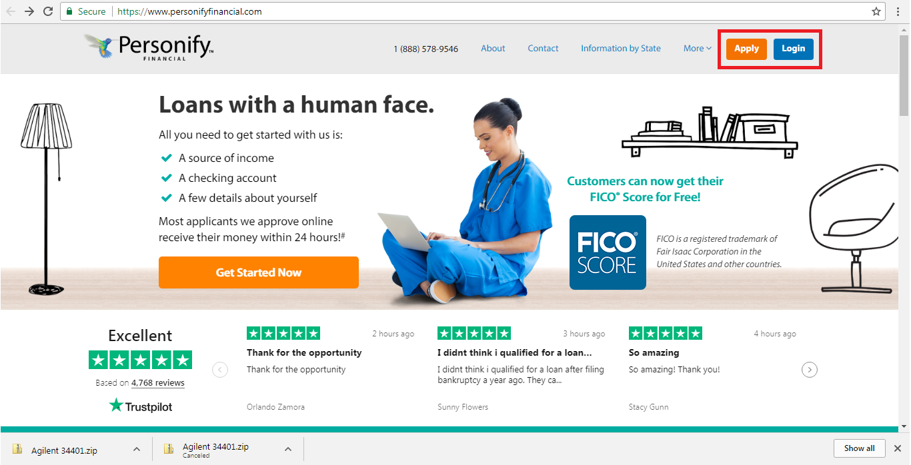

Figure 1: Home page

### **Apply**

To register for the first time, do the following:

1. Click **Apply** on the upper-right corner of the home page as shown in *Figure 1*. The registration page appears as shown in *Figure 2*.

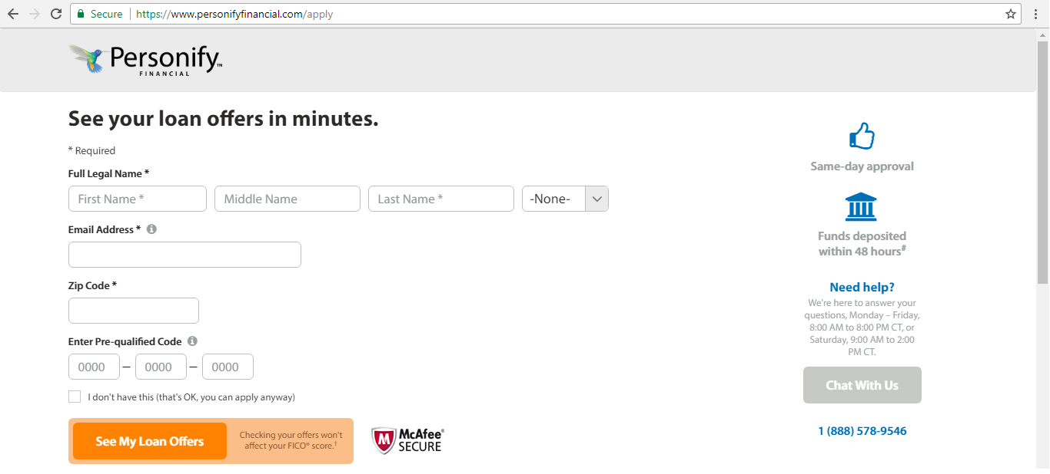

Figure 2: Registration

1. Type the first name, middle name and last name in the respective text boxes as shown in *Figure 2*.
2. Select a level from the **None** drop-down list box as shown in *Figure 3.*

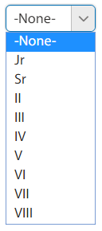

Figure 3: Level

1. Type the email ID in **Email Address** text box to send loan offer information and for further mail communication.
2. Type the zip code in **Zip Code** text box.
3. Type the pre-qualified code in the **Enter Pre-qualified Code** text box as shown in   
   *Figure 4.*

**NOTE:** The pre-qualified code is the offer sent in mail.

1. If user does not have the pre-qualified code, select the check box as shown in *Figure 4*.

**NOTE:** User can also apply without the pre-qualified code.

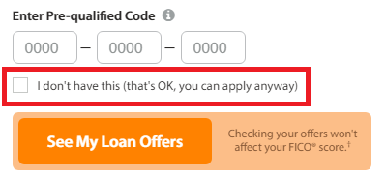

Figure 4: Pre-qualified code

1. Click **See My Loan Offers** as shown in *Figure 4*. The application link will be sent to the registered email ID.

**NOTE:** The user need to check the email ID whether the mail is received.

1. If the mail is not received, click **Send My Email** as shown in *Figure 5*. The confirmation page appears as shown in *Figure 6*.

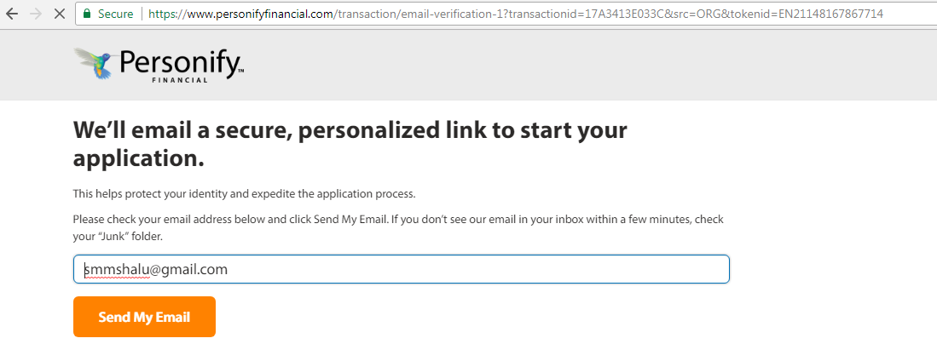

Figure 5: Send my email

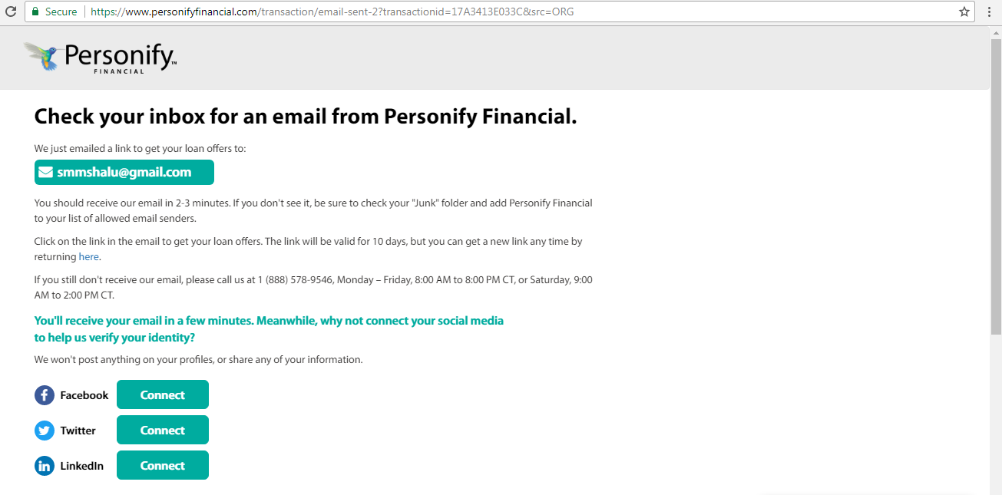

Figure 6: Check for confirmation mail

1. Check the mail ID and click the link to continue the loan application as shown in *Figure 7.*

**NOTE:** The sent link will expire in 10 days from the time this email is sent to the user.

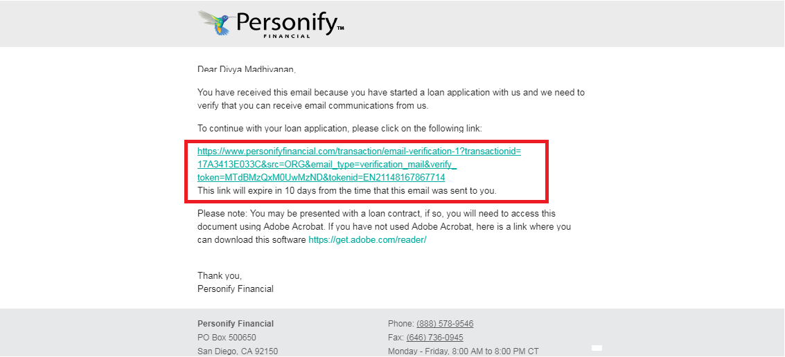

Figure 7: Registration link

The user will be directed to a page to fill the details as shown in *Figure 8*.

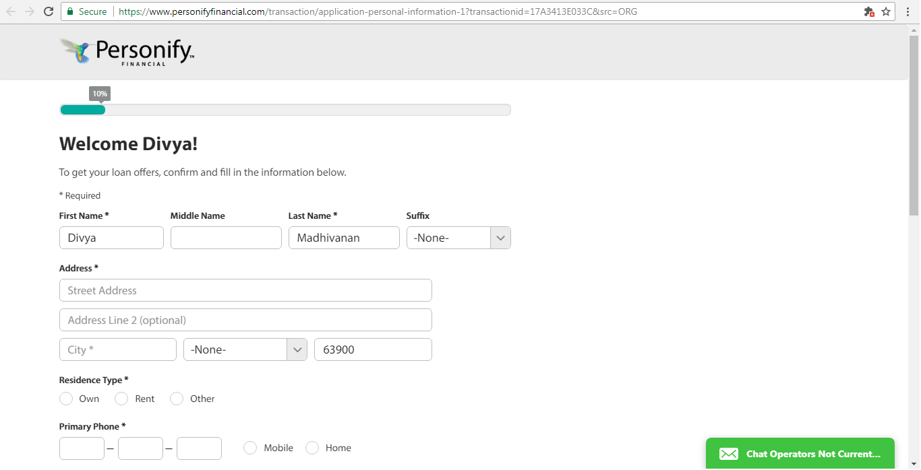

Figure 8: Fill in the information

1. Type the address in the **Address** text box and type the city name in **City** text box.
2. Select a state from the **None** drop-down list box as shown in *Figure 9*.

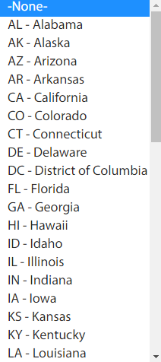

Figure 9: Select state

1. Select the type of residence from the **Residence Type** option buttons as shown in   
   *Figure 10*.
2. Select the contact type from the option button and type the phone number in the **Primary Phone** text box.
3. Follow the same procedure as mentioned in previous step for **Other Phone** if required.

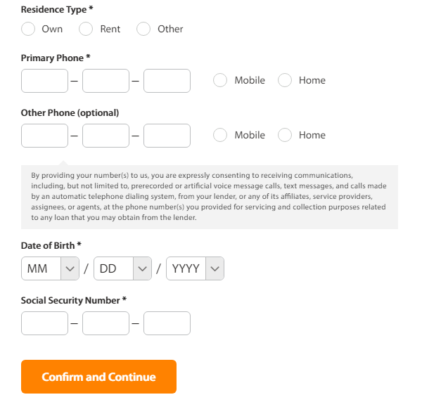

Figure 10: Confirm and Continue

1. Select month, date and year from the respective drop-down list boxes as shown in   
   *Figure 10.*
2. Type a security number in the **Social Security Number** text box as shown in *Figure 10*.
3. Click **Confirm and Continue**.

### **Login**

If user has already registered, user can access using the **Login** option.

1. Click **Login** on the upper-right corner of the home page as shown in *Figure 11.*

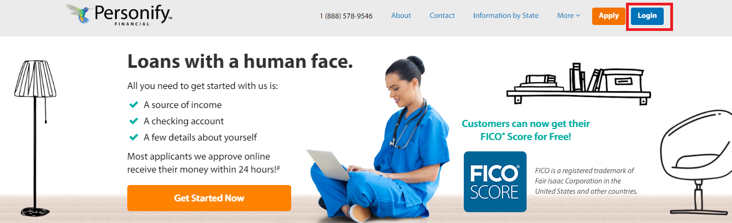

Figure 11: Login

The login page appears as shown in *Figure 12*.

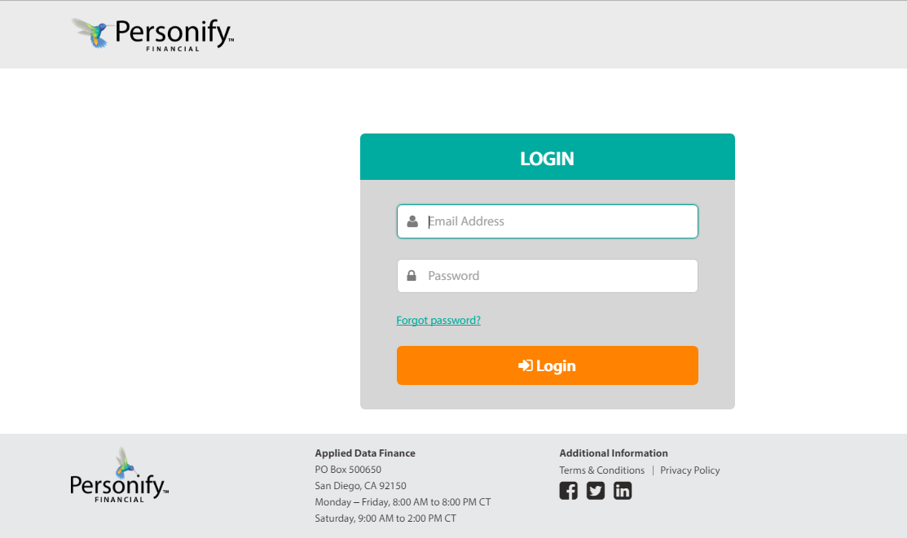

Figure 12: Login credentials

1. Type the email ID and password in the respective text boxes as shown in *Figure 12*.
2. Click **Login**.

#### **Password reset / Forgot password**

In some cases if user forget the password, user can reset the password and access the account.

1. Click **Forgot password?** The following page appears as shown in *Figure 13*.
2. Type the email ID in the **Email Address** text box and click **Send Reset Link**.

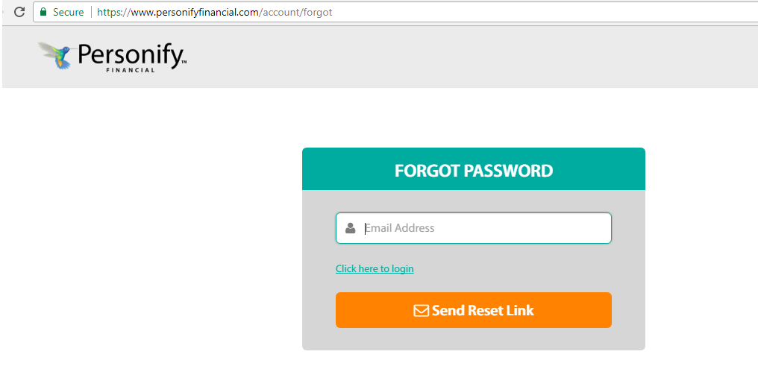

Figure 13: Forgot password

1. Check the mail and click the link to set the password.
2. Type a new password in the **New Password** text box and click **OK**. A confirmation message will be sent to your mail ID.
3. Type the new password and click **Login**.

## **Customer care contact**

Call to the toll free number on top of the home page for any queries or clarifications as shown in *Figure 14.*

### **Contact Information / Question**

Click **Contact** on top of the home page for any complaints or reviews as shown in *Figure 14*. The **Contact** **Information** page appears as shown in *Figure 15*.



Figure 14: Contact

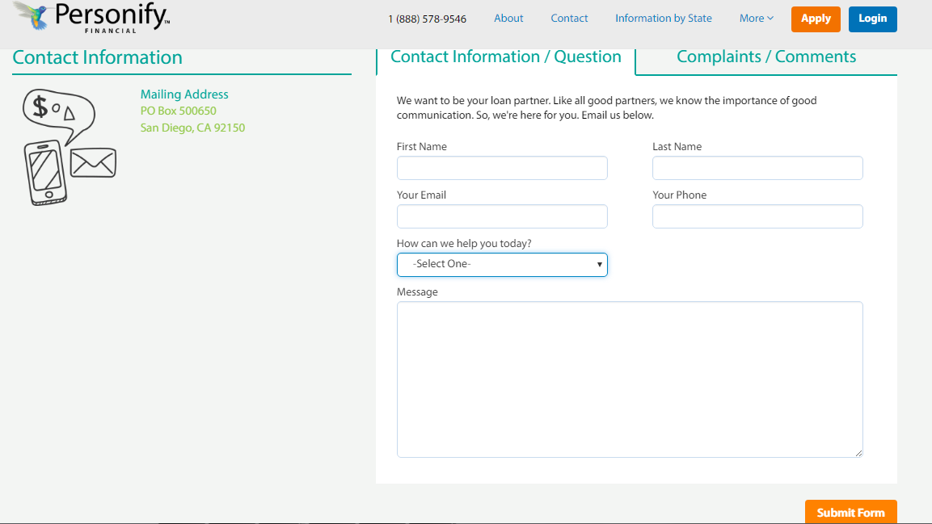

Figure 15: Contact information/question

1. Type the first name and last name in the respective text boxes as shown in *Figure 15*.
2. Type the email ID and contact number in the **Your Email** and **Your Phone** text box.
3. Select a query from the **How can we help you today?** drop-down list box as shown in *Figure 16*.

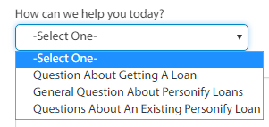

Figure 16: Select query

1. Type the required message in the **Message** text box according to the selected query and then click **Submit Form**. An acknowledgement message appears as shown in *Figure 17*.

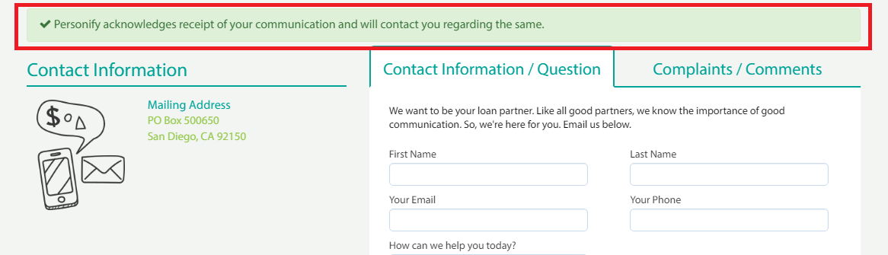

Figure 17: Acknowledgement message for query

A confirmation mail is sent to the user’s mail ID as shown in *Figure 18*. The query’s response will be sent to the user’s mail ID within 1-2 business days.

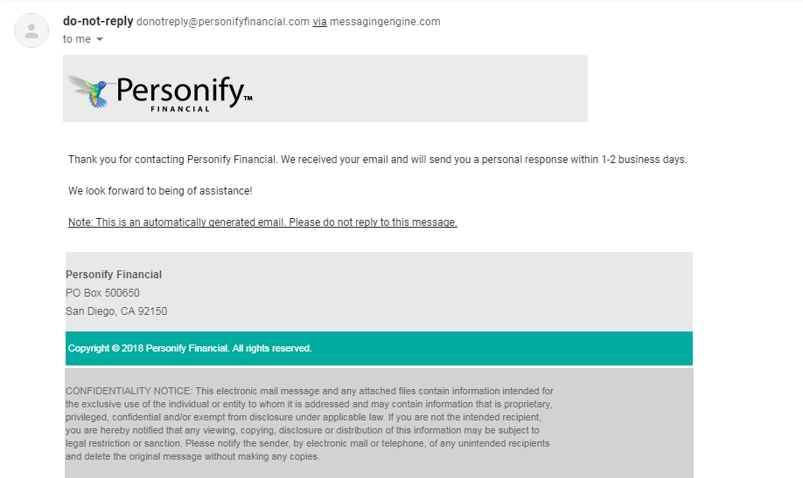

Figure 18: Response through mail

### **Complaints / Comments**

To file a complaint, do the following

1. Click the **Complaints / Comments** tab and type the name, email ID, cell phone number in the respective text boxes as shown in *Figure 19*.

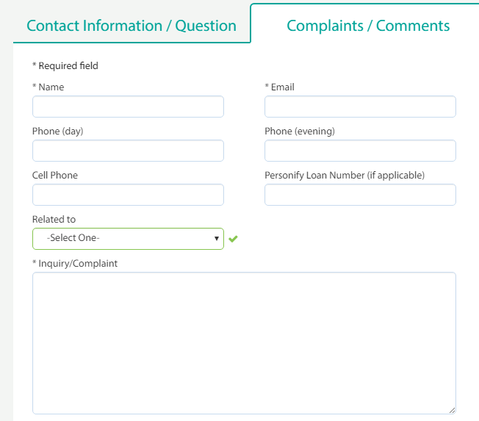

Figure 19: Complaints/comments

1. Type phone numbers in **Phone(day)** and **Phone(evening)** text boxes if required for user’s availability.
2. Type the Personify loan number in the **Personify Loan Number(if applicable)** text box if needed.
3. Select an option related to the complaint from the **Related to** drop-down list box as shown in *Figure 20*.

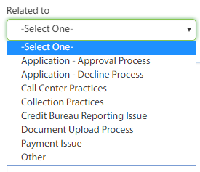

Figure 20: Options related to complaint

1. Type the complaint in the **Inquiry/Complaint** text box for the selected option as shown in *Figure 21*.

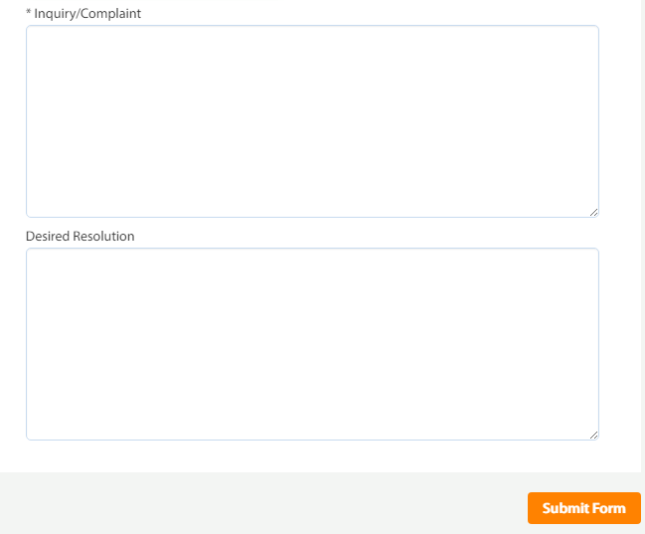

Figure 21: Submit form

1. Type the required action to be taken in the **Desired Resolution** text box and then click **Submit Form**. An acknowledgement message appears as shown in *Figure 22.*

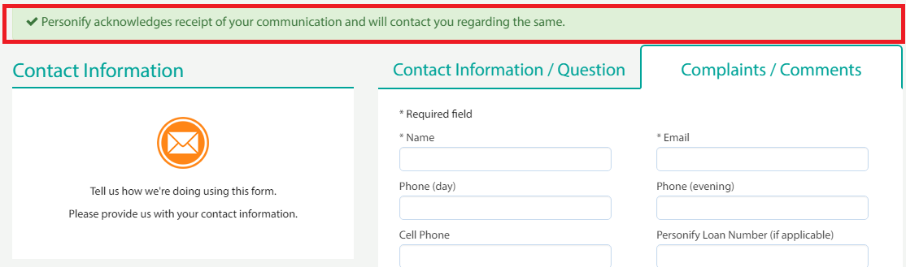

Figure 22: Acknowledgement message for complaint

A confirmation mail is sent to the user’s mail ID. The query’s response will be sent to the user’s mail ID within 1-2 business days.

### **Chat**

To chat with customer care for queries, do the following:

1. Click **Apply** on upper-right corner of the home page. The registration page appears as shown in *Figure 23*.

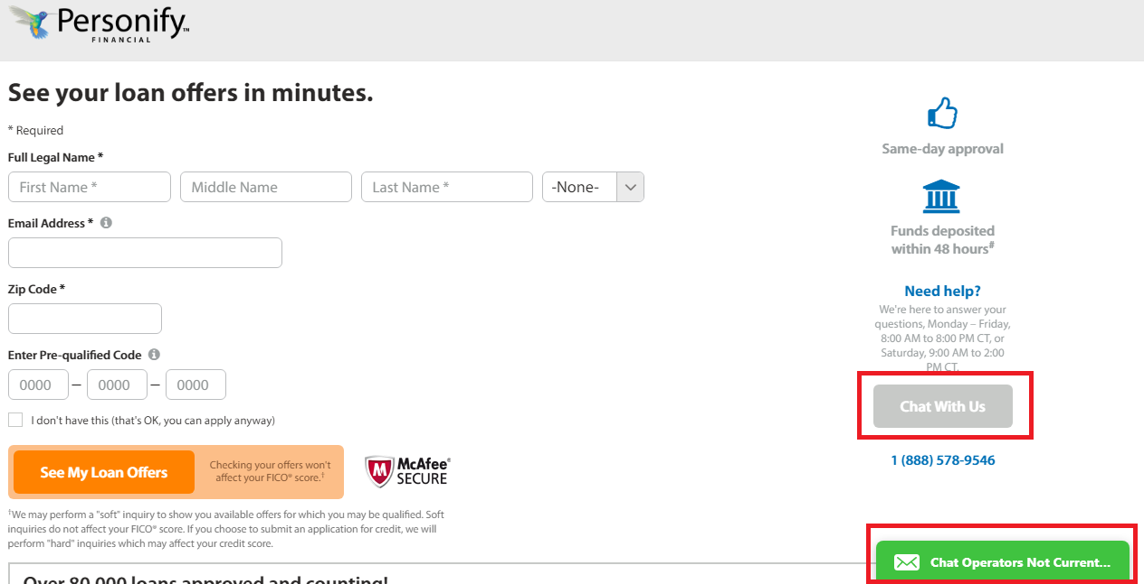

Figure 23: Chat

1. Click **Chat With Us** or click **Chat Operations** as shown in *Figure 23*. The chat window appears as shown in *Figure 24*.

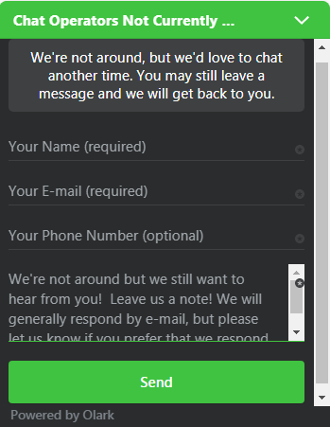

Figure 24: Chat window

**NOTE:** The chat operators may not be available sometime. Hence the user can type their name, email and phone number in the respective text boxes and send their messages. The chat operators will get back to users once they are available.

**NOTE:** The chat operator availability is displayed on top of the chat window as shown in   
*Figure 24*. For example, **Chat Operators Not Currently Available**.